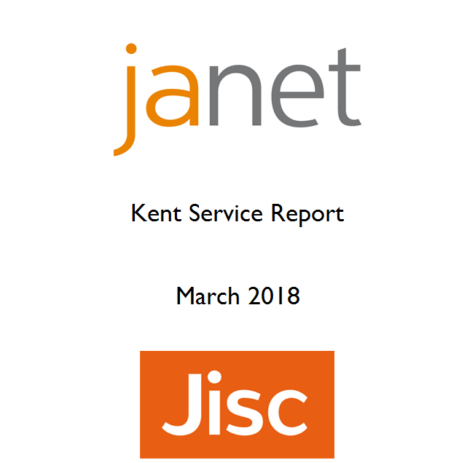
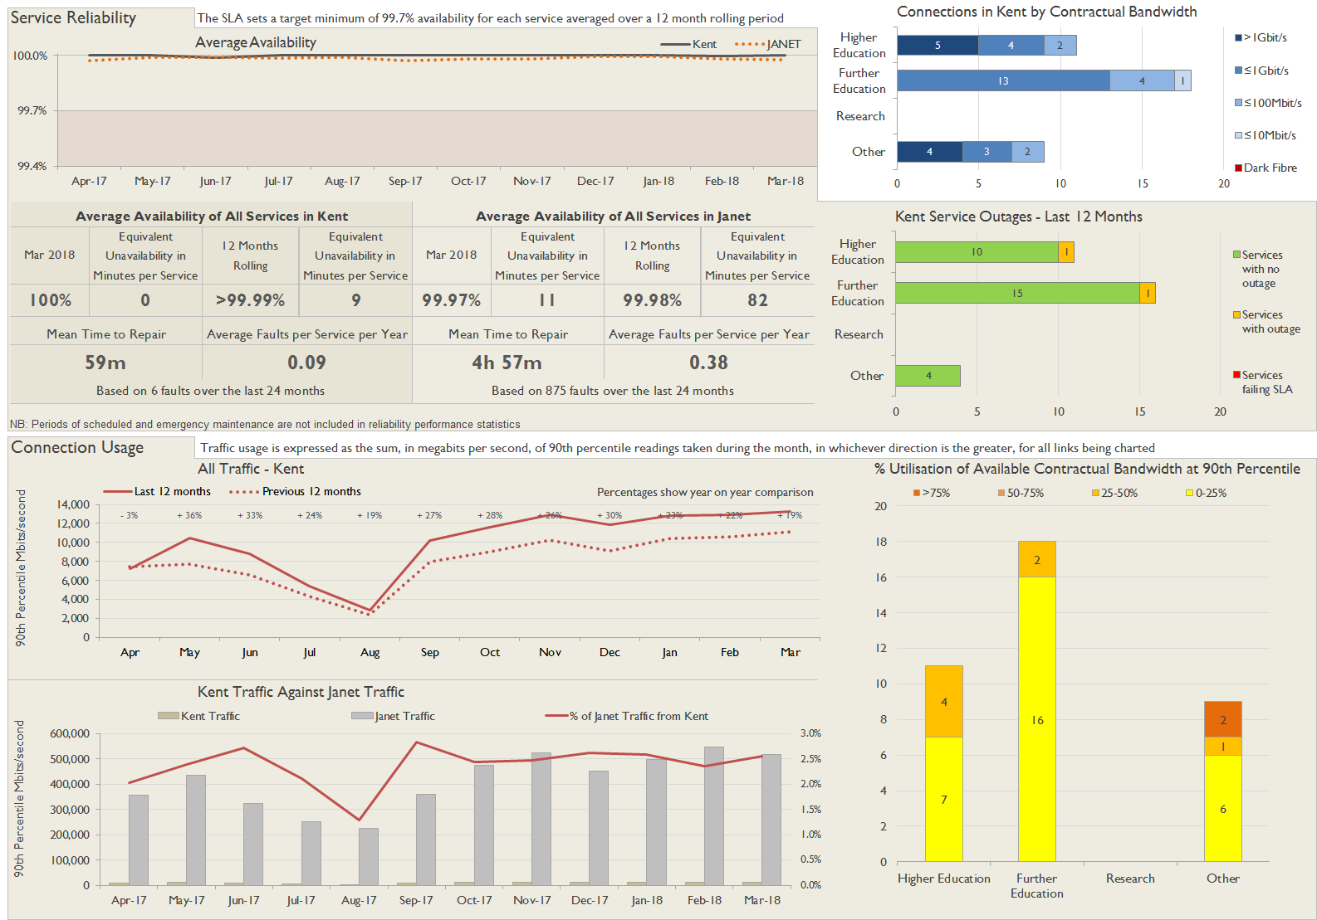
Service Availability
The SLA target sets a minimum of 99.7% availability for each customer, averaged over a 12 month rolling period
Periods of scheduled and emergency maintenance are discounted when calculating availability of services
Monthly and annual availabilities falling below 99.7% are highlighted
* Service has resilience - where an organisation retains connectivity during an outage period by means of a second connection, the outage is not counted against its availability figures
Service | Apr 17 | May 17 | Jun 17 | Jul 17 | Aug 17 | Sep 17 | Oct 17 | Nov 17 | Dec 17 | Jan 18 | Feb 18 | Mar 18 | 12 Month Rolling Availability
Canterbury Christ Church University, Broadstairs Campus | 100% | 100% | 100% | 100% | 100% | 100% | 100% | 100% | 100% | 100% | 100% | 100% | 100%
Canterbury Christ Church University, Canterbury Campus | 100% | 100% | 100% | 100% | 100% | 100% | 100% | 100% | 100% | 100% | 100% | 100% | 100%
Canterbury Christ Church University, Cornwallis Building | 100% | 100% | 100% | 100% | 100% | 100% | 100% | 100% | 100% | 100% | 100% | 100% | 100%
Canterbury College, Canterbury Campus | 100% | 100% | 100% | 100% | 100% | 100% | 100% | 100% | 100% | 100% | 100% | 100% | 100%
Canterbury College, Sheppy Campus | 100% | 100% | 100% | 100% | 100% | 100% | 100% | 100% | 100% | 100% | 100% | 100% | 100%
East Kent College, Broadstairs Campus | 100% | 100% | 100% | 100% | 100% | 100% | 100% | 100% | 100% | 100% | 100% | 100% | 100%
East Kent College, Dover Campus * | 100% | 100% | 100% | 100% | 100% | 100% | 100% | 100% | 100% | 100% | 100% | 100% | 100%
East Kent College, Folkestone Campus | 100% | 100% | 100% | 100% | 100% | 100% | 100% | 100% | 100% | 100% | 100% | 100% | 100%
Hadlow College, Canterbury Campus | 100% | 100% | 100% | 100% | 100% | 100% | 100% | 100% | 100% | 100% | 100% | 100% | 100%
Hadlow College, Greenwich Campus | 100% | 100% | 100% | 100% | 100% | 100% | 100% | 100% | 100% | 100% | 100% | 100% | 100%
Hadlow College, Hadlow Campus | 100% | 100% | 100% | 100% | 100% | 100% | 100% | 100% | 100% | 100% | 100% | 100% | 100%
Hadlow College, Mottingham Campus | 100% | 100% | 100% | 100% | 100% | 100% | 99.96% | 100% | 100% | 100% | 99.83% | 100% | 99.98%
Hilderstone College | 100% | 100% | 100% | 100% | 100% | 100% | 100% | 100% | 100% | 100% | 100% | 100% | 100%
Kent County Council * | 100% | 100% | 100% | 100% | 100% | 100% | 100% | 100% | 100% | 100% | 100% | 100% | 100%
Kent County Council, Data Centre * | 0.00% | 0.00% | 0.00% | 0.00% | 0.00% | 0.00% | 100% | 100% | 100% | 100% | 100% | 100% | <12 Months
Medway Council | 100% | 100% | 100% | 100% | 100% | 100% | 100% | 100% | 100% | 100% | 100% | 100% | 100%
MidKent College, Maidstone Campus | 100% | 100% | 100% | 100% | 100% | 100% | 100% | 100% | 100% | 100% | 100% | 100% | 100%
MidKent College, Ormskirk | 100% | 100% | 100% | 100% | 100% | 100% | 100% | 100% | 100% | 100% | 100% | 100% | 100%
NIAB | 100% | 100% | 100% | 100% | 100% | 100% | 100% | 100% | 100% | 100% | 100% | 100% | 100%
North Kent College, Dartford Campus | 100% | 100% | 100% | 100% | 100% | 100% | 100% | 100% | 100% | 100% | 100% | 100% | 100%
North Kent College, Gravesend Campus | 100% | 100% | 100% | 100% | 100% | 100% | 100% | 100% | 100% | 100% | 100% | 100% | 100%
The London Institute of Banking & Finance, Kent Campus | 100% | 100% | 100% | 100% | 100% | 100% | 100% | 100% | 100% | 100% | 100% | 100% | 100%
University for the Creative Arts, Canterbury Campus | 100% | 100% | 100% | 100% | 100% | 100% | 100% | 100% | 100% | 100% | 100% | 100% | 100%
University for the Creative Arts, Rochester Campus | 100% | 100% | 100% | 100% | 100% | 100% | 100% | 100% | 100% | 100% | 100% | 100% | 100%
University of Greenwich, The Universities at Medway | 100% | 100% | 100% | 100% | 100% | 100% | 100% | 100% | 100% | 100% | 100% | 100% | 100%
University of Kent, Canterbury Campus | 100% | 100% | 100% | 100% | 100% | 100% | 100% | 100% | 100% | 100% | 100% | 100% | 100%
University of Kent, CCCU Rochester House | 100% | 100% | 100% | 100% | 100% | 100% | 100% | 100% | 100% | 100% | 100% | 100% | 100%
University of Kent, Tonbridge Campus | 100% | 100% | 100% | 100% | 100% | 100% | 100% | 100% | 100% | 100% | 100% | 100% | 100%
University of London, Maidstone Studios | 100% | 100% | 99.56% | 100% | 100% | 100% | 100% | 100% | 100% | 100% | 100% | 100% | 99.96%
West Kent and Ashford College, Ashford Campus | 100% | 100% | 100% | 100% | 100% | 100% | 100% | 100% | 100% | 100% | 100% | 100% | 100%
West Kent and Ashford College, Tonbridge Campus | 100% | 100% | 100% | 100% | 100% | 100% | 100% | 100% | 100% | 100% | 100% | 100% | 100%
Workers' Educational Association, Southern | 100% | 100% | 100% | 100% | 100% | 100% | 100% | 100% | 100% | 100% | 100% | 100% | 100%
Connection outages for current month
Maintenance outages are included in this table - only unscheduled maintenance is counted against availability.
Some of the outages reported below are on circuits which are not connected through the selected region - they appear in the table because they are part of a service whose primary connection does belong to this region.
Connection | Start Date and Time | End Date and Time | Parking  hh:mm | Duration  hh:mm | Fault Type | Description
Hadlow College, Mottingham Campus | 16/03/2018 00:14 | 16/03/2018 00:34 | 00:00 | 00:20 | Customer Environment | Wide area power outage
NIAB | 19/03/2018 21:31 | 20/03/2018 10:45 | 00:00 | 13:14 | Customer Environment | Customer local power outage
Link Utilisation of Contractual Bandwidth
The table shows utilisation at the 90th percentile, i.e. for 90% of the samples within the period the traffic was at or below the level shown and for 10% of the samples traffic was above the level shown. The figure therefore gives a reasonable indication of the loading of the connection during the busiest periods. The measurements are shown as a percentage of the available contractual bandwidth, and only the highest of the to/from readings for the month is used.

Connection | Current Bandwidth | Apr-17 | May-17 | Jun-17 | Jul-17 | Aug-17 | Sep-17 | Oct-17 | Nov-17 | Dec-17 | Jan-18 | Feb-18 | Mar-18
Canterbury Christ Church University, Broadstairs Campus | 1Gbit/s | 3% | 3% | 2% | 2% | 2% | 3% | 3% | 3% | 2% | 3% | 3% | 3%
Canterbury Christ Church University, Canterbury Campus | 4Gbit/s | 10% | 9% | 7% | 7% | 6% | 28% | 34% | 37% | 33% | 28% | 35% | 35%
Canterbury Christ Church University, Cornwallis Building | 4Gbit/s | <0.5% | 1% | <0.5% | 1% | <0.5% | <0.5% | <0.5% | 1% | 1% | 1% | <0.5% | 1%
Canterbury College, Canterbury Campus | 1Gbit/s | 11% | 28% | 20% | 6% | 4% | 17% | 22% | 25% | 15% | 26% | 20% | 25%
Canterbury College, Sheppy Campus | 100Mbit/s | 8% | 17% | 13% | 3% | 2% | 9% | <0.5% | <0.5% | <0.5% | <0.5% | 0% | 0%
East Kent College, Broadstairs Campus | 1Gbit/s | 1% | 3% | 3% | 1% | 1% | 3% | 3% | 3% | 1% | 4% | 3% | 4%
East Kent College, Dover Campus | 1Gbit/s | 0% | 0% | 0% | 0% | 0% | 0% | 0% | 0% | 0% | 0% | 0% | <0.5%
East Kent College, Dover Campus | 1Gbit/s | 0% | 0% | 0% | 0% | 0% | 0% | 0% | 0% | 0% | 0% | 0% | <0.5%
East Kent College, Folkestone Campus | 1Gbit/s | 4% | 6% | 6% | 2% | 2% | 6% | 6% | 8% | 6% | 9% | 8% | 9%
Hadlow College, Canterbury Campus | 100Mbit/s | 5% | 12% | 13% | 2% | 1% | 10% | 13% | 15% | 3% | 15% | 9% | 14%
Hadlow College, Greenwich Campus | 100Mbit/s | 2% | 4% | 3% | 1% | 1% | 3% | 4% | 5% | 1% | 5% | 4% | 4%
Hadlow College, Hadlow Campus | 1Gbit/s | <0.5% | <0.5% | <0.5% | <0.5% | <0.5% | <0.5% | <0.5% | <0.5% | <0.5% | <0.5% | <0.5% | <0.5%
Hadlow College, Mottingham Campus | 100Mbit/s | 4% | 16% | 11% | 2% | 1% | 8% | 14% | 16% | 2% | 15% | 10% | 15%
Hilderstone College | 100Mbit/s | 1% | 1% | 1% | 1% | 1% | 1% | 1% | 1% | 1% | 42% | 50% | 1%
Kent County Council, Canterbury (1) | 2Gbit/s | 77% | 160% | 142% | 126% | 13% | 73% | 72% | 86% | 87% | 87% | 86% | 89%
Kent County Council, Canterbury (2) | 2Gbit/s | 6% | 6% | 5% | 4% | 3% | 1% | 1% | 2% | 1% | 2% | 2% | 1%
Kent County Council, Data Centre, MSER via Canterbury | 1Gbit/s | 0% | 0% | 0% | 0% | 0% | 0% | <0.5% | <0.5% | <0.5% | <0.5% | <0.5% | <0.5%
Kent County Council, Data Centre, MSER via Maidstone | 1Gbit/s | 0% | 0% | 0% | 0% | 0% | 0% | <0.5% | <0.5% | <0.5% | <0.5% | <0.5% | <0.5%
Kent County Council, Maidstone (1) | 10Gbit/s | 10% | 19% | 18% | 17% | 6% | 20% | 21% | 24% | 23% | 24% | 24% | 24%
Kent County Council, Maidstone (2) | 1Gbit/s | 17% | 20% | 19% | 18% | 8% | 21% | 22% | 24% | 25% | 27% | 28% | 30%
London South East Colleges, Orpington Campus | 1Gbit/s | 0% | 0% | 0% | 0% | 0% | 0% | 0% | 3% | 2% | 3% | 3% | 3%
Medway Council | 10Gbit/s | 16% | 27% | 21% | 21% | 7% | 22% | 717% | 25% | 27% | 3% | 3% | 3%
MidKent College, Maidstone Campus | 1Gbit/s | 8% | 16% | 14% | 1% | 1% | 8% | 12% | 13% | 7% | 14% | 12% | 13%
MidKent College, Ormskirk, Medway Campus | 1Gbit/s | 14% | 28% | 26% | 11% | 5% | 17% | 20% | 23% | 16% | 24% | 20% | 21%
NIAB | 100Mbit/s | 24% | 22% | 19% | 22% | 23% | 26% | 90% | 45% | 33% | 26% | 25% | 77%
North Kent College, Dartford Campus | 1Gbit/s | 8% | 24% | 16% | 3% | 3% | 13% | 21% | 24% | 20% | 24% | 24% | 26%
North Kent College, Gravesend Campus | 1Gbit/s | 4% | 8% | 6% | 2% | 1% | 5% | 7% | 9% | 8% | 10% | 9% | 10%
The London Institute of Banking & Finance, Kent Campus | 40Mbit/s | 29% | 30% | 29% | 29% | 29% | 34% | 43% | 44% | 42% | 48% | 45% | 44%
University for the Creative Arts, Canterbury Campus | 1Gbit/s | 5% | 6% | 2% | 2% | 2% | 6% | 8% | 10% | 6% | 9% | 9% | 8%
University for the Creative Arts, Rochester Campus | 1Gbit/s | 5% | 7% | 3% | 2% | 2% | 7% | 10% | 9% | 6% | 8% | 8% | 9%
University of Greenwich, The Universities at Medway | 2Gbit/s | 6% | 6% | 6% | 6% | 6% | 6% | 9% | 9% | 7% | 8% | 8% | 9%
University of Kent, Canterbury Campus | 10Gbit/s | 36% | 41% | 33% | 10% | 10% | 37% | 14633% | 49% | 46% | 49% | 48% | 50%
University of Kent, CCCU Rochester House | 10Gbit/s | <0.5% | <0.5% | <0.5% | <0.5% | <0.5% | <0.5% | <0.5% | <0.5% | <0.5% | <0.5% | <0.5% | <0.5%
University of Kent, Tonbridge Campus | 100Mbit/s | <0.5% | <0.5% | <0.5% | 2% | 1% | <0.5% | <0.5% | <0.5% | <0.5% | 1% | <0.5% | <0.5%
University of London, Maidstone Studios | 1Gbit/s | 26% | 26% | 27% | 27% | 28% | 28% | 28% | 27% | 27% | 31% | 34% | 31%
West Kent and Ashford College, Ashford Campus | 1Gbit/s | 1% | 2% | 1% | <0.5% | <0.5% | <0.5% | <0.5% | <0.5% | <0.5% | <0.5% | <0.5% | <0.5%
West Kent and Ashford College, Tonbridge Campus | 1Gbit/s | 4% | 12% | 8% | 2% | 2% | 7% | 12% | 17% | 3% | 17% | 13% | 15%
Workers' Educational Association, Southern | 10Mbit/s | 0% | 0% | 0% | 0% | 0% | 0% | 0% | 0% | 4% | 6% | 5% | 5%

