Configuring Sending of Operator Name in CISCO ISE 2.0 for eduroam
(Aaron Street, The Pirbright Institute : edited by Alan Buxey, eduroam UK)
By default, Cisco ISE servers do not have the correct attribute set up for insertion of the Operator-Name attribute. However, the steps to achieve this are straight forward in the GUI. The first step involves editing the dictionary so the option is available and then to apply this to the appropriate RADIUS server sequence.
Enabling the option is carried out using the ISE dictionaries. The option for Operator-Name is 126 so the first step is to configure this and enable it so it is displayed as a choice later on.
First open up the dictionary section under the policy menu
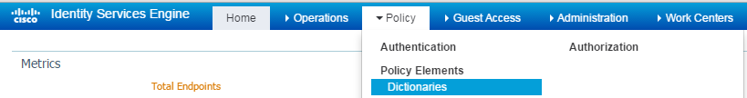
Once in the dictionaries expand system and then RADIUS until you see IETF sub menu and click on ‘Dictionary Attributes’ option on the right-hand pane.
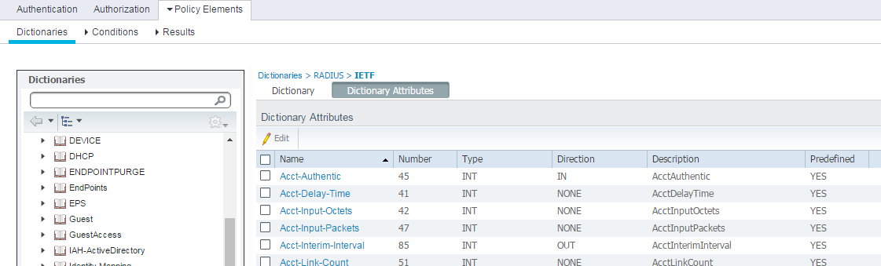
..
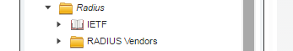
(Note sometimes it takes a moment to populate and scrolling the scroll-bar slightly seems to help)
Once you can see all the attributes find option 126 that will be show as “Undefined_attribute_126”, tick the check-box next to it and edit it as below clicking save.
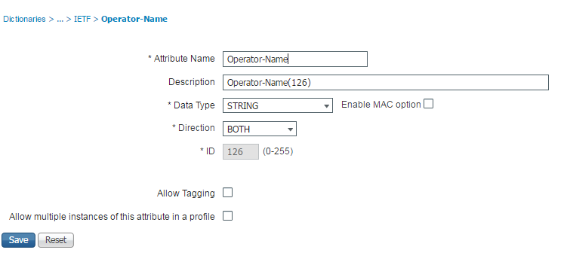

Applying the option.
Under the ‘Administration’ menu, ‘Network Resources’ sub-menu, click on “RADIUS Server Sequences”
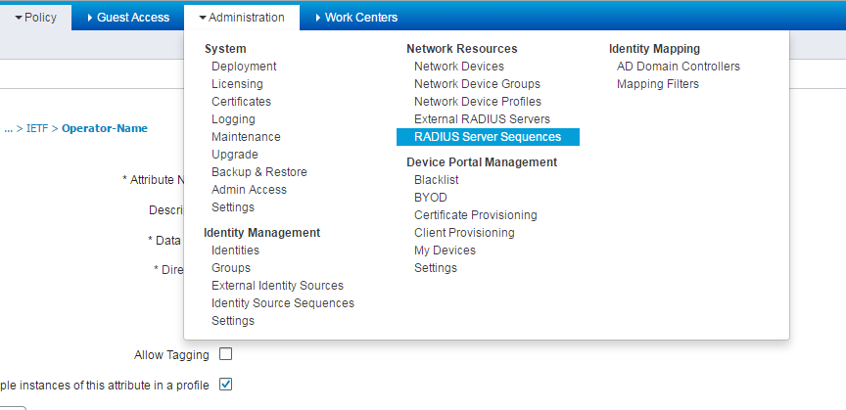
Select the sequence you have set up for proxying to the Janet NRPS, and once open move to the ‘Advanced Attribute Settings’, from here tick the check-boxes to modify the attributes, choose “Add” and in the drop down box select RADIUS Operator-Name—[126]. Making it equal to your realm preceded by the digit 1. (e.g. camford.ac.uk becomes 1camford.ac.uk)
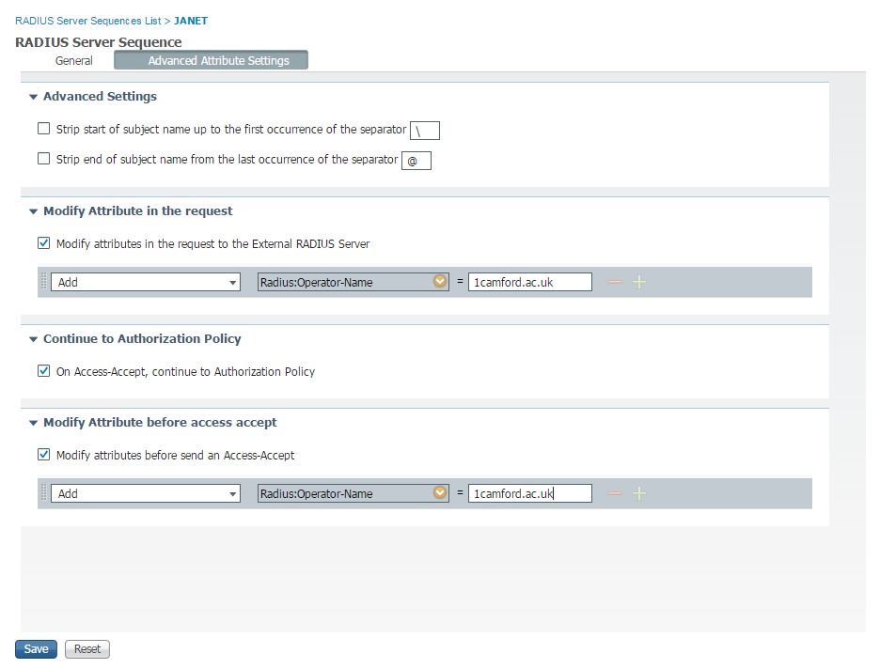
Click ‘Save’ and your server will now be sending the correct Operator name to the Janet NRPS. This can be tested using the visitor test process as outlined at the bottom of the test page of your organisations account at https://support.eduroam.uk and then checking under the minor issues after a short period where, if successful, you will no longer be alerted to an incorrect, or absence of, Operator Name.
